5/7/15
Initial plumbing fixtures submittals sent in.
SS-1 Non-Adaptable shower stall was Fiberfab model 48C-N, and an alternate option for Aquatic 1483CST. Both had large thresholds. Fiberfab model had a 46” opening, Aquatic had a 42” opening.
SS-2 Adaptable shower stall was Fiberfab 48BFFWA, and an alternate option for Aquatic 1483BFSD. Both had low-profile thresholds and a 46” interior opening.

5/22/15
Email titled “Hadley - Plumbing Fixture - Dual Flush ADA compliant” sent in regards to the owner being interested in Aquatic 14832P, which has a tile look. Waiting for determination regarding SS-2.

6/4/15
Email titled “Hadley - Alternate Pricing” sent regarding alternate pricing for Owner/Architect selected showers. I included a note that said: “You need to make sure the architect and/or ADA consultant review the bathtubs/showers for ADA and adaptability requirements. It’s our experience that different architects and ADA consultants have different interpretations of the code. For the showers I’ve tried to include as many different options for the size and threshold.”

6/5/15
Fixture submittal response came back with the following comments:
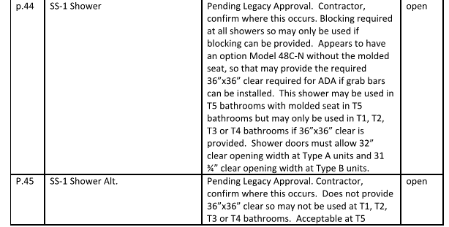

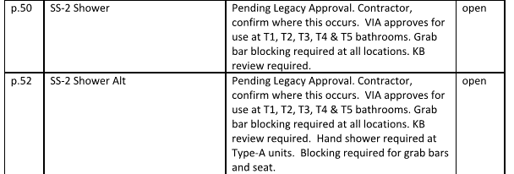

6/8/15
Email titled “Plumbing Submittal - Accessibility Review”. Owner is interested in using Aquatic 1423CTC for SS-1 and 1483EN for SS-2.

6/11/15
Email titled “Plumbing Submittal - Accessibility Review”. The following is from the architect:
• 1423CTC Shower is approved for use in non-accessible bathrooms in Type A or Type B units. However, this shower is 42” wide rather than 48” wide as per the wall dimensions. Confirm with Steffenie about changing the wall framing to fit this 42” tub or using the 48” wide model 1483CST instead.
• 1483EN Shower is approved for use in accessible bathrooms in Type B units
• There are no showers in accessible bathrooms in Type A units

6/24/15
Email titled “Hadley - Plumbing Fixtures REV2 06-23-15”. Owner is interested in using Aquatic 1423CTC for SS-1 and 1483CST for SS-2.

